End-User Courses

No. | Steps | Details | Completed
1 | Prepare the system before installing Acumatica ERP. | - One of the supported versions of Windows is installed on your laptop. For details, see One of the supported versions of Windows is installed on your laptop.  - The needed Web Server (IIS) features are configured. For details, see The needed Web Server (IIS) features are configured.  - One of the supported versions of Microsoft SQL Server is installed on your laptop. For details, see Microsoft SQL Server is installed on your laptop.
2 | The needed version of Acumatica ERP is installed on your laptop. | Acumatica ERP 2019 R12  For details, see The needed version of Acumatica ERP is installed on your laptop.
3 | The required dataset is installed. | U100  For details, see The required dataset is installed.
4 | The training guide and files for training are downloaded and are on your laptop. | Training guide and files for training are next to the course description on the course page.

Frequently Asked Questions

One of the supported versions of Windows is installed on your laptop.
Requirements:
- Windows 7 64-bit edition
- Windows 8 64-bit edition
- Windows 10 64-bit edition

How can I find out which version of Windows I am running on my computer?
- Type about in the search box on your taskbar, and then select About your PC.
- Look under PC for Edition to find out which version and edition of Windows your PC is running.
- Look under PC for Version to find out which version of Windows your PC is running.
- Look under PC for System Type to see if you're running a 32-bit or 64-bit version of Windows.

The needed Web Server (IIS) features are configured.
Requirements:
- Web Management Tools > IIS Management Console
- World Wide Web Services
  - Application Development Features > .NET Extensibility
  - Application Development Features > ASP.NET
  - Application Development Features > ISAPI Extensions
  - Application Development Features > ISAPI Filters
  - Common HTTP Features > Default Document
  - Common HTTP Features > Static Content
  - Performance Features > Dynamic Content Compression
  - Performance Features > Static Content Compression
  - Security > Request Filtering
Make sure, that for each application pool you are planning to use with Acumatica ERP 2019 R1 version or higher, the Enable 32-bit Applications parameter is set to False (the parameter is located under the IIS Manager > Application Pools > Edit Application Pool > Advanced Settings menu).

How do I configure the Web Server (IIS) features?
- Type Windows Features in the search box on your taskbar, and then select Turn Windows features on or off.
- Open Internet Information Services, and select all the required Web Server (IIS) features.
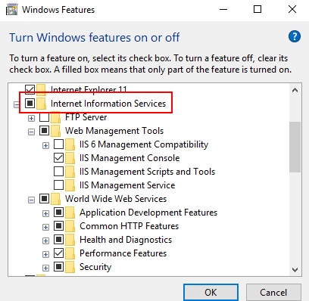

Microsoft SQL Server is installed on your laptop.
Requirements:
- Microsoft SQL Server Express edition (preferred for training)
- Microsoft SQL Server 2017
- Microsoft SQL Server 2016
- Microsoft SQL Server 2014 64-bit edition
- Microsoft SQL Server 2012 64-bit edition

How can I find out which version of Microsoft SQL Server is installed on my computer?
- Type Apps in the search box on your taskbar, and then select Apps & Features.
- In the window that opens, find Microsoft SQL Server and verify that the one of the required versions is listed.
Where can I find a free version of Microsoft SQL Server to install?
If you don’t have the Microsoft SQL Server installed, use the following link to download the trial version of it: https://www.microsoft.com/en-us/sql-server/sql-server-downloads. We highly recommended that you install the Express Edition of Microsoft SQL Server for learning purposes.

The needed version of Acumatica ERP is installed on your laptop.
How can I verify the Acumatica ERP version that is installed?
- Run the Acumatica ERP Configuration Wizard. For example, select Start > Acumatica > Acumatica ERP Configuration.
- On the Welcome page, verify that the required version is installed, as shown in the screenshot below
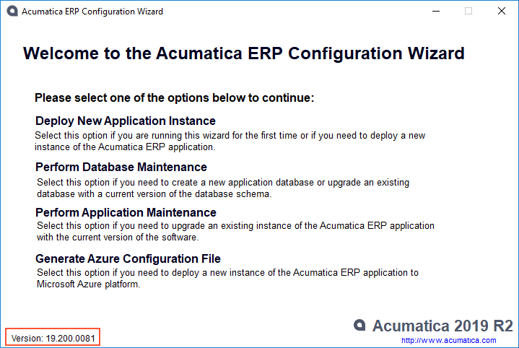
How should I install Acumatica ERP?
- Download Acumatica ERP 2019 R2 (select Version>Acumatica ERP>AcumaticaERPInstall.msi) and run the .msi file.
- On the Welcome page, click Next.
- On the License Agreement page, read the license agreement. To accept the license agreement, click I Agree.
- Click Next.
- On the Main Software Configuration page, select the Launch the Acumatica ERP Configuration Wizard check box to continue deploying the Acumatica ERP application instance once you install the Acumatica ERP Tools.
- Click Next.
- On the Select Installation Folder page, specify the location where you want to install Acumatica ERP Tools, and then click Next.
- On the Confirm Installation page, click Next.
- If you did not select the Launch the Acumatica ERP Configuration Wizard check box in Step 5, click Close when you’re prompted.

The required dataset is installed.
What should I do if I don't remember what dataset I have chosen or if I have chosen the wrong dataset while installing a company?
- Run the Acumatica ERP Configuration Wizard.
- On the Welcome page, click Perform Application Maintenance.
- On the Application Maintenance page, select the instance created for training, and click Company Maintenance.
- On the SQL Server Authentication page, specify the authentication method that this application instance of Acumatica ERP will use to connect to the database, and click OK.
- On the Company Setup page, select the Advanced Settings check box.
- For the company with the Visible status, in the Insert Data column, select the required dataset, and click Next.
- In the warning dialog box that appears, click Yes.
- On the Tables Configuration page, click Next.
- On the Confirm Configuration page, click Finish.
The system will start the process of changing the dataset. This process will overwrite the information you had on that instance.

What should I do if I didn’t install any instance and company with the required dataset?
To deploy an Acumatica ERP Instance, locate and follow the instructions from the online Help as follows:
- Perform the steps from the instructions on the following Help topic: To Deploy an Acumatica ERP Instance.

